Power Management for Embedded System

Power management is a critical aspect of designing and operating Arduino and embedded systems, particularly for battery-powered applications where energy efficiency is paramount. Effective power management involves selecting appropriate batteries, employing hardware and software strategies to minimize power consumption, and implementing best practices to extend battery life.

**Types of Batteries**

1. **Alkaline Batteries:**
   * **Pros:** Widely available, low cost, and easy to replace.
   * **Cons:** Limited lifespan, non-rechargeable, and relatively high internal resistance.
   * 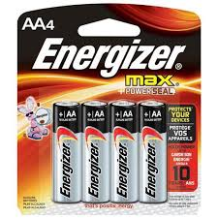
2. **Lithium-Ion (Li-ion) Batteries:**
   * **Pros:** High energy density, lightweight, and rechargeable.
   * **Cons:** Requires complex charging circuitry, potential safety risks if mishandled.
   * 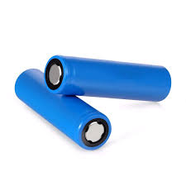
3. **Lithium Polymer (Li-Po) Batteries:**
   * **Pros:** Flexible shapes and sizes, high energy density, and rechargeable.
   * **Cons:** Sensitive to overcharging and physical damage, needs specialized charging circuits.
   * 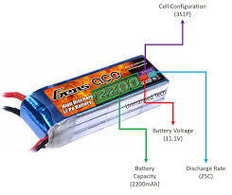
4. **Nickel-Metal Hydride (NiMH) Batteries:**
   * **Pros:** Rechargeable, relatively safer than Li-ion, and available in standard sizes.
   * **Cons:** Lower energy density compared to Li-ion, self-discharge rate is higher.
   * 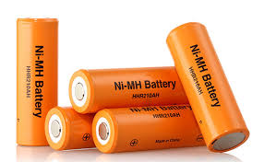
5. **Coin Cell Batteries:**
   * **Pros:** Compact size, suitable for low-power applications.
   * **Cons:** Limited capacity and non-rechargeable.
   * 

**Hardware Power Management**

1. **Voltage Regulators:**
   * **Linear Regulators:** Simple but inefficient, as excess energy is dissipated as heat.
   * **Switching Regulators:** More efficient, converting excess voltage into current, reducing power loss.
2. **Power Switches:**
   * **MOSFETs:** Used for switching power on and off to various parts of the circuit to conserve energy.
   * **Relays:** Can be used for high power switching but are slower and consume more power.
3. **Low-Power Microcontrollers:**
   * **Arduino Pro Mini:** Can operate at lower voltages and has low power modes.
   * **ATmega328P:** Supports various sleep modes to conserve energy.
4. **Sensors and Peripherals:**
   * **Low-Power Sensors:** Selecting sensors with low standby currents.
   * **Power Management ICs:** Specialized ICs for battery management and efficient power distribution.

**Software Power Management**

1. **Sleep Modes:**
   * **Idle Mode:** The CPU stops while peripherals continue to operate.
   * **Power-Down Mode:** Most of the chip’s functions are stopped, significantly reducing power consumption.
   * **Standby Mode:** Faster wake-up than power-down mode with a bit more power consumption.
2. **Dynamic Frequency Scaling:**
   * Adjusting the clock speed of the microcontroller according to the processing requirement to save power.
3. **Peripheral Management:**
   * Enabling/disabling peripherals as needed to conserve energy.
4. **Code Optimization:**
   * Efficient coding practices to minimize CPU cycles and power consumption.

**Practicing Good Power Management: Example**

**Remote Weather Station:** An example of practicing good power management can be seen in a remote weather station powered by a Li-ion battery. Here are the steps and techniques used:

1. **Hardware Selection:**
   * **Microcontroller:** Use of an Arduino Pro Mini operating at 3.3V, which consumes less power than the 5V version.
   * **Sensors:** Selection of low-power sensors like the BME280 for temperature, humidity, and pressure measurements.
   * **Voltage Regulation:** Use of a buck converter to step down from the battery voltage to 3.3V efficiently.
2. **Software Techniques:**
   * **Sleep Modes:** The microcontroller is programmed to enter deep sleep mode between sensor readings.
   * **Wake-Up Triggers:** Using a real-time clock (RTC) to wake the microcontroller at predefined intervals.
   * **Efficient Code:** Optimized code to quickly read sensor data and send it to a remote server before going back to sleep.
3. **Operational Strategy:**
   * **Data Logging Intervals:** Adjusting data logging intervals based on power availability and application requirements.
   * **Power Profiling:** Monitoring the current consumption and adjusting the system configuration to optimize power usage.

By combining these strategies, the remote weather station can operate for extended periods on a single battery charge, illustrating effective power management in an Arduino-based embedded system.

**Conclusion**

Effective power management for Arduino and embedded systems involves a holistic approach encompassing the selection of suitable batteries, efficient hardware design, and optimized software techniques. By integrating these elements, developers can significantly enhance the battery life and performance of their applications, making them more reliable and sustainable for long-term use.